1. Connection

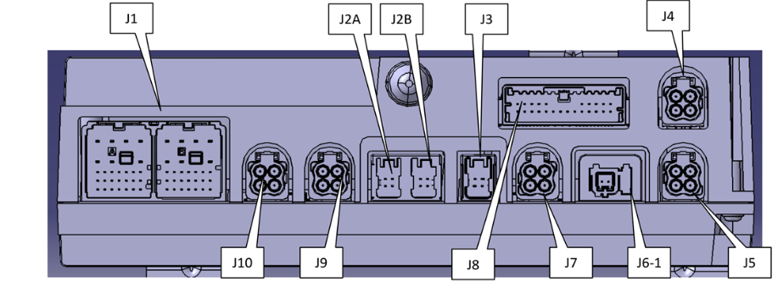

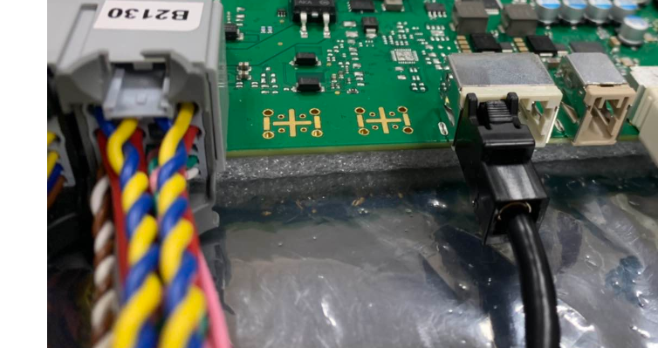

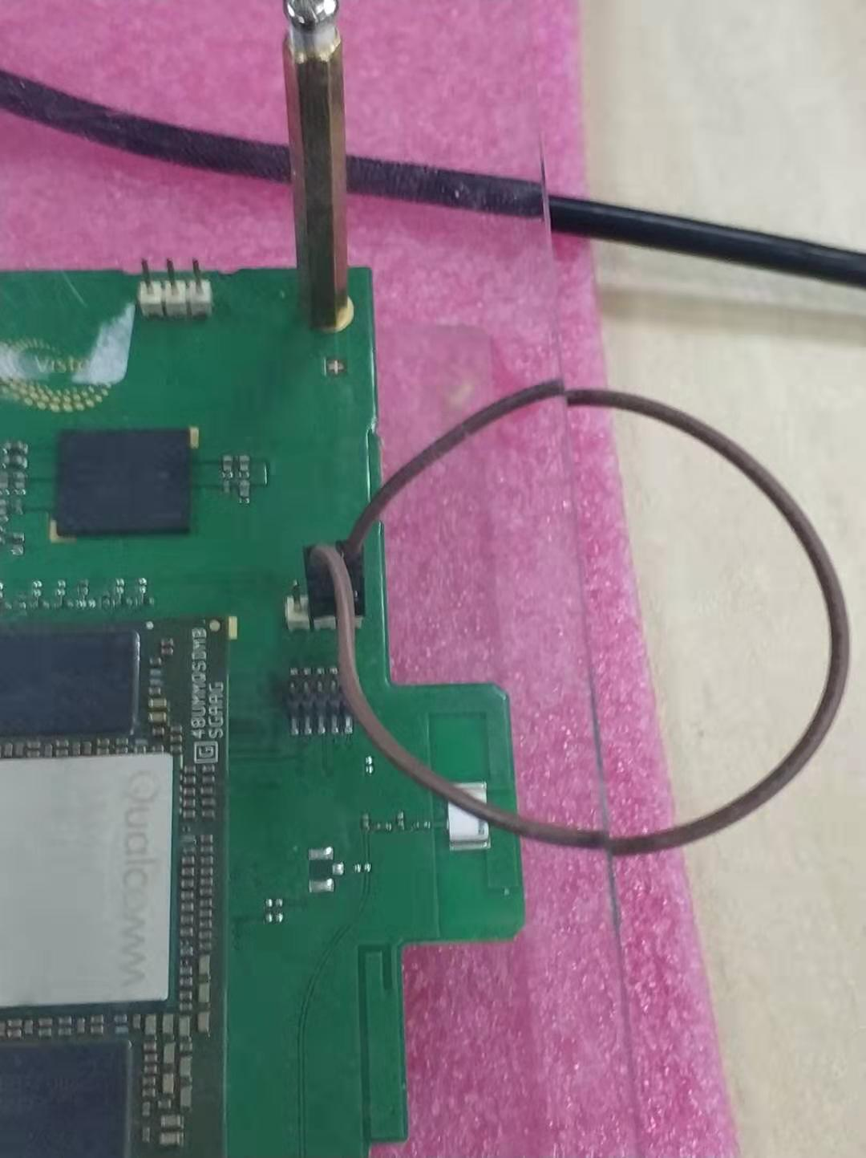

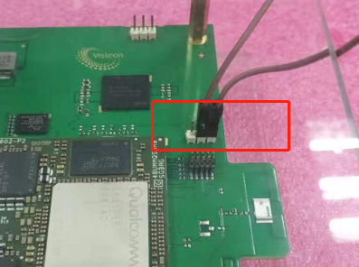

1. Provision operation (DONOT provison every times, depends on your board status)

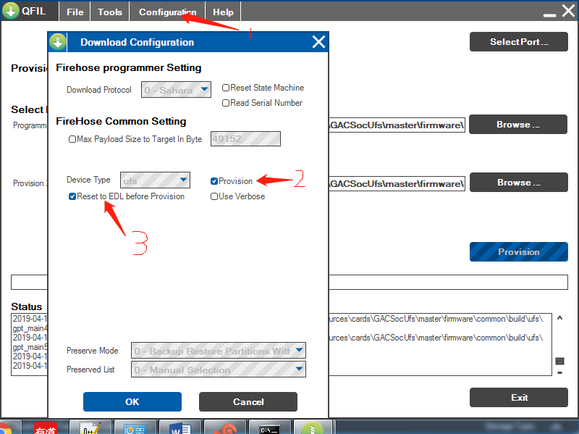

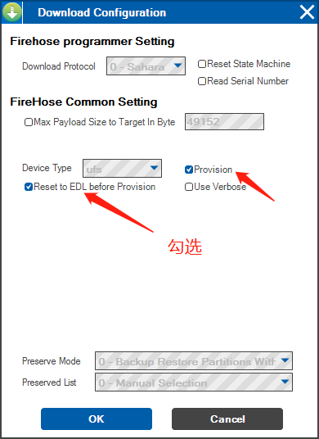

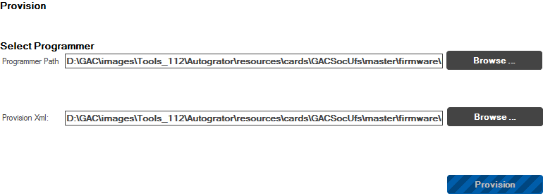

ddr:

D:\GAC\images\Tools_112\Autogrator\resources\cards\GACSocUfs\master\firmware\boot_images\QcomPkg\SDMPkg\855\Bin\AU\RELEASE\prog_firehose_ddr.elf

Provision file:

D:\GAC\images\Tools_112\Autogrator\resources\cards\GACSocUfs\master\firmware\common\config\ufs\provision\provision_toshiba.xml

1. Unzip soc version (for example GAC-Image--ci.fpf.GAC.dev.MAIN.Build_#112,unzip to D:\GAC, path will be subject to you actually extract).select path to load configuration files.

Programmer path:

D:\GAC\Tools\Autogrator\resources\cards\GACSocUfs\master\firmware\boot_images\QcomPkg\SDMPkg\855\Bin\AU\RELEASE\prog_firehose_ddr.elf

CDT config:

D:\GAC\Tools\Autogrator\resources\cards\GACSocUfs\master\firmware\boot_images\QcomPkg\SDMPkg\855\Bin\AU\RELEASE\adp_0_1.0.bin

Content xml:

D:\GAC\Tools\Autogrator\resources\cards\GACSocUfs\master\firmware\contents.xml

1. Open QFIL, select META build, according to flowing step to load the file: (DONOT provison every times, depends on your board status)

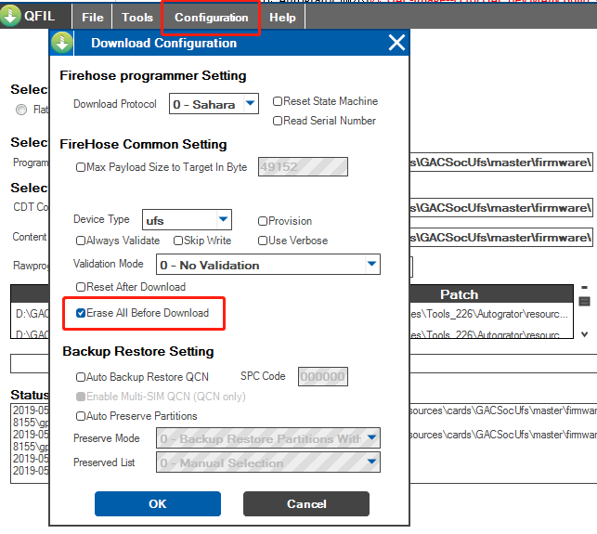

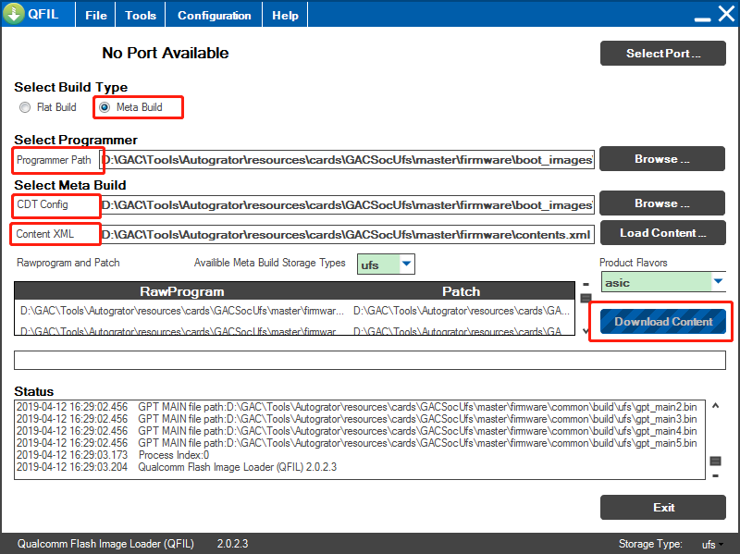

1. (DONOT provison every times, depends on your board status) short pin then power on the target, when 9008 port shows in the tools, click QFIL Download Content, Wait for the completion of the flash, then unplug the jumper.

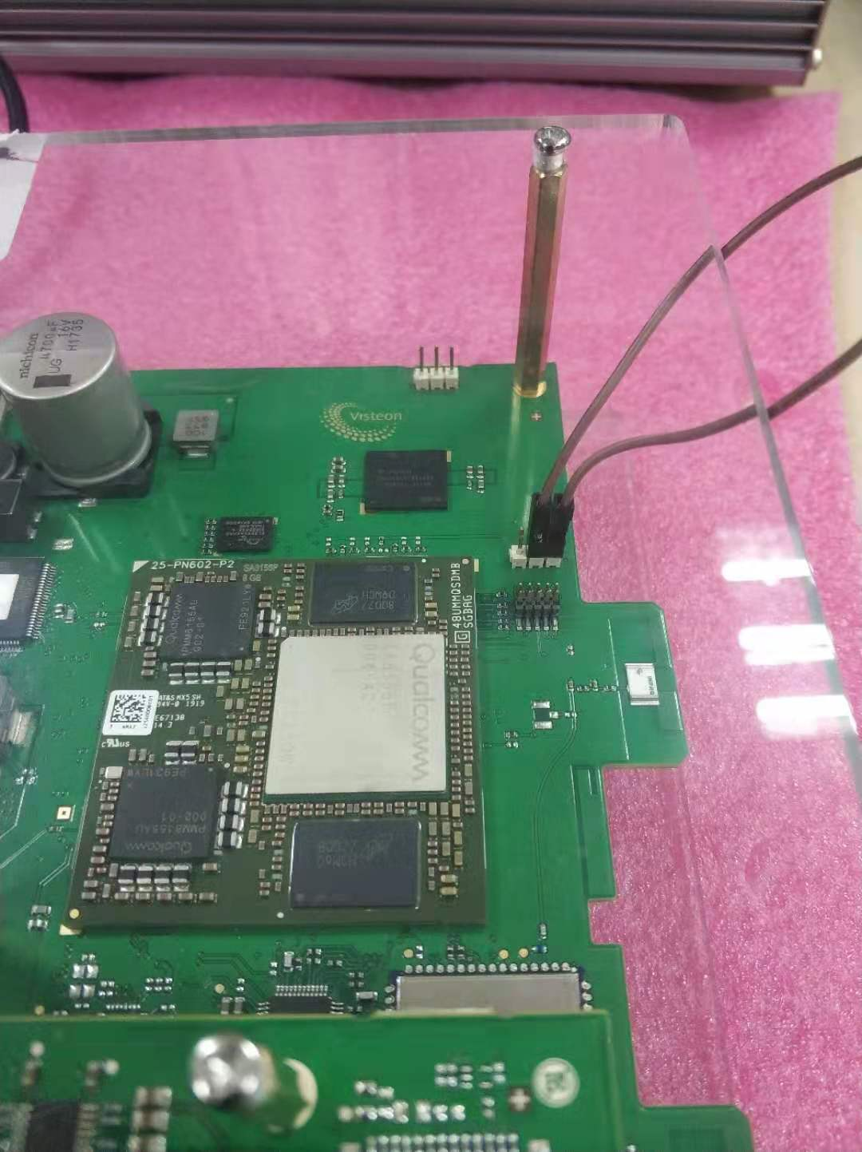

1. (flash on Ubuntu platform) power circle, press down key to enable target’s fastboot mode.

find -name "adp_0_1.0.bin"

sudo fastboot flash cdt <PATH>/adp_0_1.0.bin

echo y | sudo ./Autogrator.sh deploy --cardName GACSocUfs --device fastboot

(flash on windows platform)



When it finished, the target will restart automatically.